**ECS PROJECT REPORT-2 (REVIEW 2)**

# EC ID: 241107

**Title: Military Drone Team: (5 scope)**

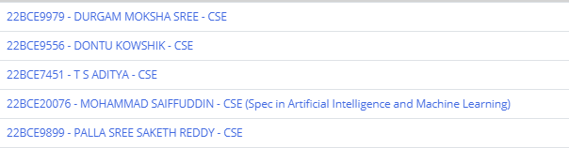

#### Sub -Teams and Parts:

**Hardware Team:**

**22BCE9899 - PALLA SREE SAKETH REDDY – CSE (sub-part lead)**

**Algorithm Team:**

**SLAM and Mission Planner:**

**22BCE20076 - MOHAMMAD SAIFFUDDIN – AI/ML (sub-team lead)**

**22BCE9556 - DONTU KOWSHIK – CSE (Project Lead)**

**Deep learning:**

**22BCE9979 - DURGAM MOKSHA SREE – CSE (sub-part Lead)**

**Communication Team:**

**22BCE7451 - T S ADITYA – CSE (sub-part lead)**

**Guide: Prof. Bolem Sai Chandana**

**Objectives Covered:**

* Autonomous GPS Navigation
* Audio and UI based Instruction driven
* Tracing the path on Map and YOLO detection of points of Exploration

**Current Status:**

A quadcopter drone with SpeedyBee F405 V4 Flight Controller which is well tuned and tested with an Remote Controller (RC) is installed with the Gazebo 7 RO2 HUMBLE Simulated codes and a base level website is made to communicate with the drone that uses Web Sockets are Built. A descent level testing is made and ended Modular approach of RAD process model opted successfully.

**Tasks Accomplished:**

**Our AI-driven drone project progressed through the RAD (Rapid Application Development) process, focusing on agile and iterative development stages**

**Hardware part:**

* **Work done:**

1. successfully constructing the drone Fig 1 using the **SpeedyBee F405 V4** flight controller, paired with **920KV brushless motors** for efficient thrust. For connectivity and control, we incorporated **ELRS (ExpressLRS)** and an **M10 GPS module** for precise navigation. Powering the system is a robust **5000mAh 4S LiPo battery**, providing sufficient flight endurance. This setup establishes a solid foundation for deploying AI capabilities, paving the way for subsequent development in autonomous navigation and obstacle detection.

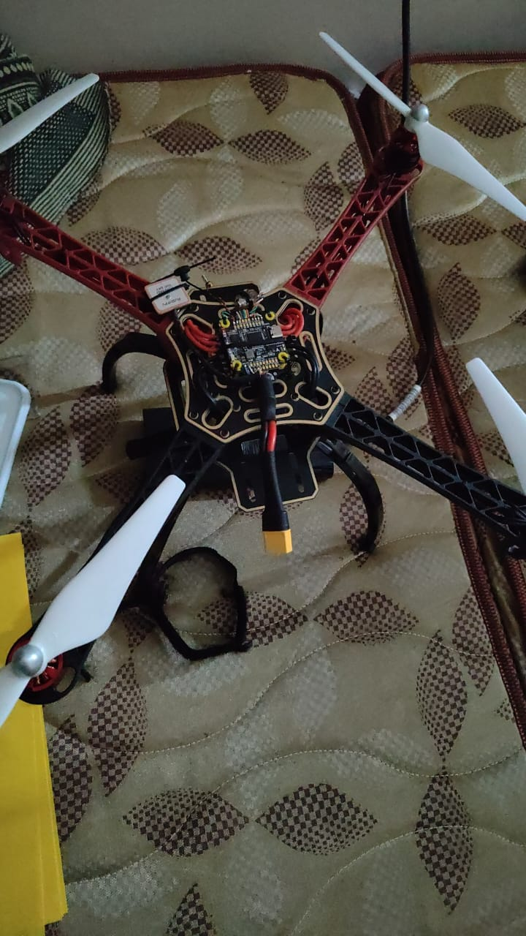 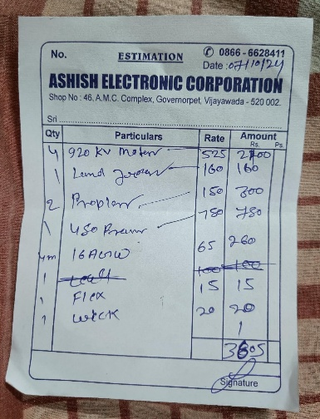 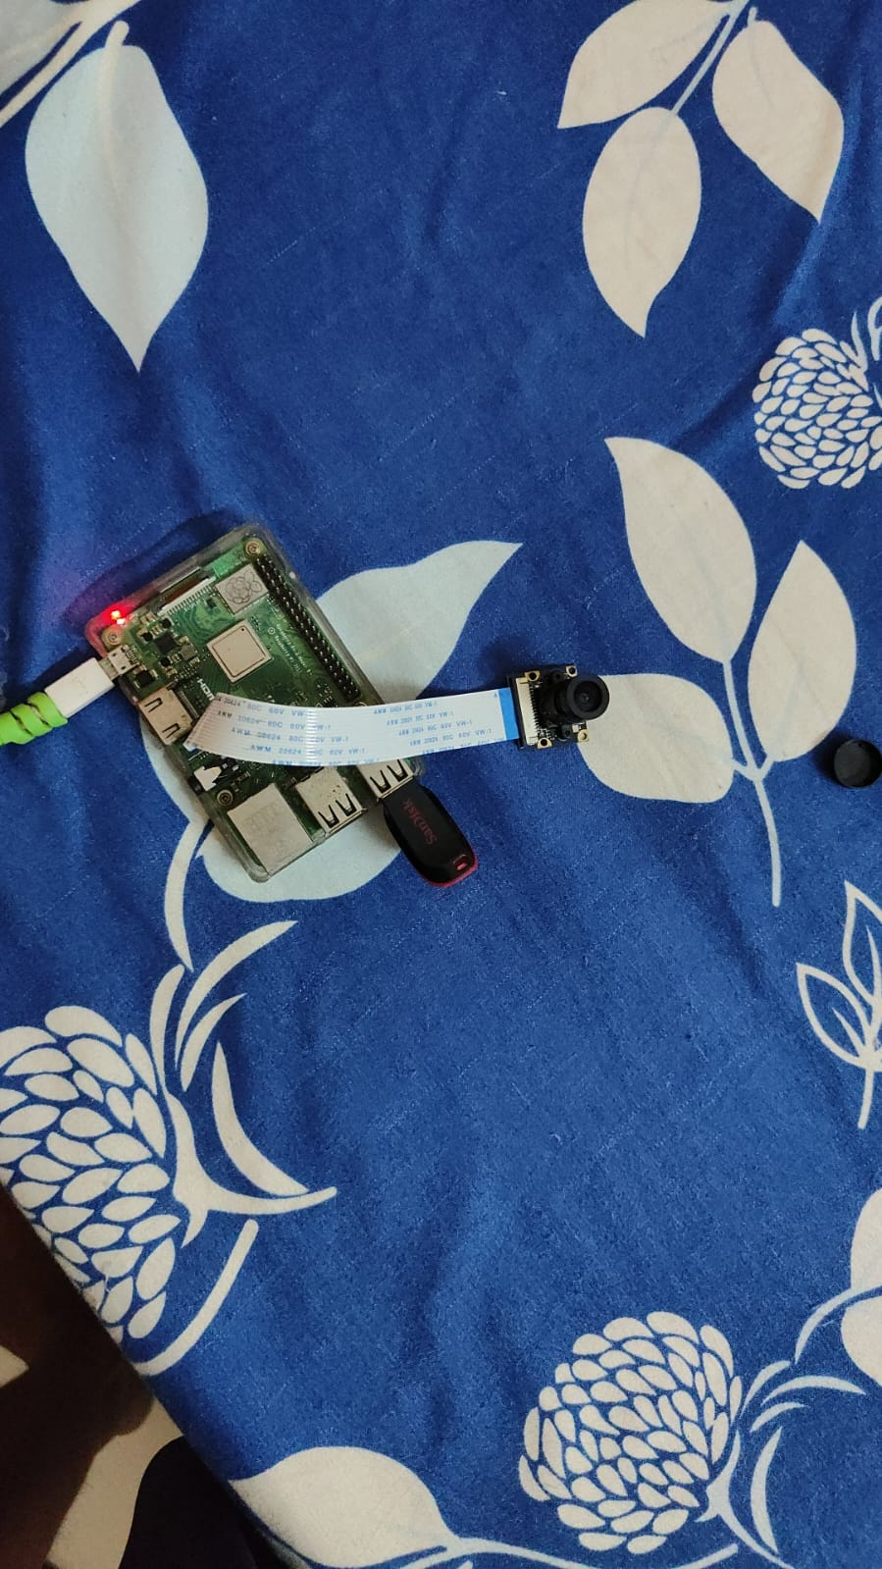

**Fig1: Drone Fig2: Purchase Bill Fig3: Raspi 4**

1. The Raspberry Pi 4 ( Fig 3) is connected to a 5MP NoIR night vision camera equipped with an IR filter, allowing for enhanced low-light imaging. The setup communicates with the flight controller via I2C established over USB, enabling streamlined data transfer. The flight controller runs on ArduPilot firmware, supporting stable autonomous functions and sensor integration for the drone.

**Algorithm Part:**

**Mission Planner:**

1. The algorithm team developed a simulation environment using **Gazebo 7 and ROS Humble,** constructing a detailed Iris drone model with a **gimbal system**. This simulation allows for realistic testing of drone dynamics and control algorithms, providing a controlled environment to refine navigation, stabilization, and camera-based functions. The setup is crucial for validating AI-driven navigation and obstacle detection before deploying on the actual hardware
2. We successfully implemented **GPS waypoint navigation** by integrating efficient path-planning algorithms, including All-Pairs Shortest Path and Minimal Spanning Tree, to optimize route efficiency. Using **DroneKit Python**, these planners enable the drone to autonomously navigate between waypoints with minimal energy consumption and time. This setup ensures precise and reliable waypoint transitions, laying the groundwork for more complex autonomous missions in dynamic environments.
3. The drone, equipped with a **PiCamera2,** leverages the **YOLOv8n model** to detect doors and windows in real time. As the drone identifies these features during flight, it marks them on a 2D map, creating a detailed layout of detected structures. This mapping capability is crucial for autonomous navigation in indoor environments, allowing the drone to recognize points of entry and exits accurately and adjust its course as needed.
4. To visualize the path followed by the drone, we utilized **the Google Maps API** to trace its GPS coordinates throughout the mission. The API allowed us to dynamically display waypoints, path segments, and **real-time drone location on a map** interface. This integration provides an intuitive overview of the drone's route, assisting in analyzing flight paths, waypoint accuracy, and mission planning adjustments.

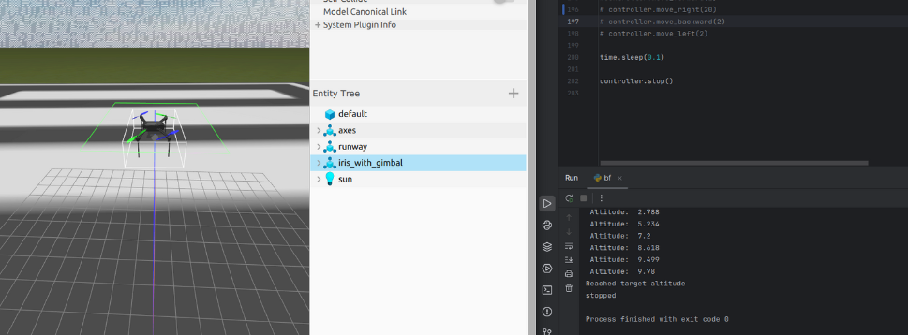

**Fig 4: Simulation and Code testing in Gazebo 7 in ROS2 HUMBLE**

**Deep learning:**

1. We prepared a **custom dataset** for detecting **open doors, closed doors, staircases, and windows**, crucial for the drone’s autonomous navigation tasks. Using the RoboFlow platform, we annotated images across these four classes, ensuring consistency and accuracy in labeling. The dataset comprises **1,560 training images, 149 validation images, and 74 testing images,** providing a well-balanced sample set to train and validate our model effectively. This structured dataset supports high model accuracy in real-world scenarios where precise detection of entrances and pathways is essential.

**Dataset link** : <https://app.roboflow.com/moksha-ydnti/doors-lfmul/1>

1. We trained a **compact YOLOv8n** model optimized for deployment on the Raspberry Pi, achieving **high accuracy in detecting windows**, decent accuracy for staircases and closed doors, and lower accuracy for open doors. The model’s lightweight architecture makes it suitable for real-time inference on edge devices, while its performance across classes will guide further adjustments to enhance detection consistency, particularly for challenging open-door cases

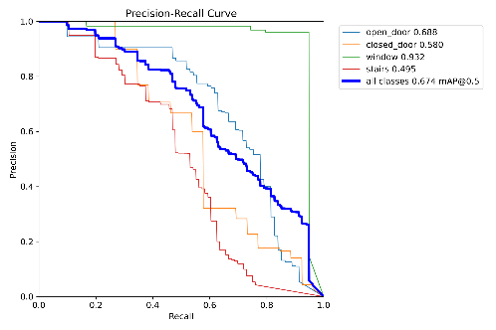 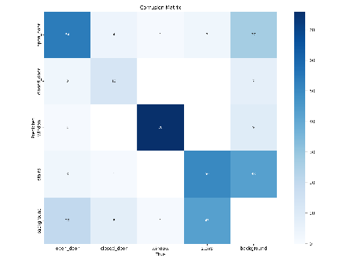 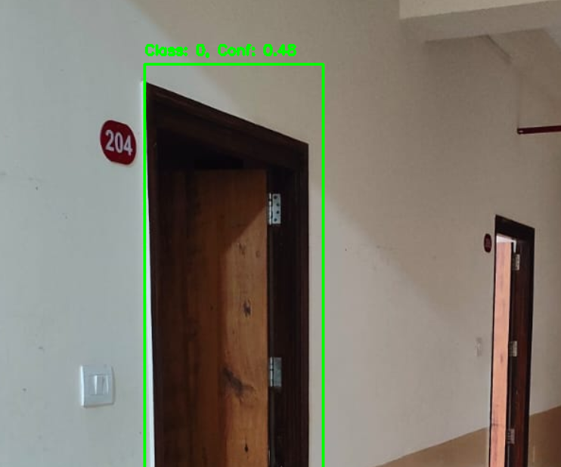

**Fig 5: P-R Curves Fig 6: Confusion Matrix Fig 7: YOLOV8n on MH3 door**

**Communication part:**

1. A foundational **website** was developed with **WebSocket** functionality, enabling real-time audio command transmission to the drone and **video streaming** from the drone’s camera. This setup allows users to give **voice instructions**, which the system interprets and sends to the drone instantly. Additionally, the site facilitates mission management by appending tasks to a priority queue, which a dedicated **MissionPlanner class** object then processes. Custom classes handle the execution, prioritization, and coordination of these missions, ensuring efficient and organized task flow for autonomous drone operations.

## Hardware Components Used:

**Flight Controller**: Speedybee F405 V3 + 4 in 1 Esc Stack *1

**Companion Computer:** Raspberry pi 4 *1

**Frame:** Plastic 3D printed or readymade X frame *1

**Guards:** DIY Quadcopter F450 550 Propeller Guards *4

**Motors:** A2212 1000 KV BLDC Brushless DC Motor *4

**Camera:** Infrared IR Night Vision Surveillance Camera Module 500W webcam *1

**Battery:** 11.1 V 3000mah 3S 25C-30C Lithium Polymer Battery *1

**LED indicators:** Red and Green LEDs *2

**Receiver:** SpeedyBee Nano 2.4G ExpressLRS (ELRS) Receiver *1

**and wiring**

# Software Components Used:

#### Operating Systems:

Raspbian Os for Raspiberry Pi 4

#### Firmware:

Ardupilot for Flight Controller

#### Frameworks:

* **Flask Server:**

Raspi receiving commands from ground station

#### React js:

Ground station website Framework

#### Simulation Tools:

* Gazebo7 with ROS2 Humble

## Budget:

## Speedy Bee F405 V4 with 4 in 1 ESC Stack: ₹ 5,900 /- *1 = ₹ 5,900/-

## 920 KV MOTORS : ₹ 525/- * 4 = ₹ 2,100/-

## LANDING GARE : ₹ 160/- *1 = ₹ 160/-

## Propellers : ₹ 150/- *2 = ₹ 300/-

## Frame : ₹ 780/- *1 = ₹ 780/-

## 16 American Gauge Wire : ₹ 65/- *4m = ₹ 260/-

## Flux : ₹ 15/-*1 = ₹ 15/-

## Wick : ₹ 20/- *1 = ₹ 20/-

## 4s Li – po Battery : ₹2,650/- *1 = ₹ 2,650/-

## RushFpv M10 GPS with Compass : ₹ 1,600/- *1 = ₹ 1,600/-

## ExpressElrs : ₹ 1,200/- *1 = ₹ 1,200/-

## HMC5883L 3 axis Compass : ₹ 180/- *1 = ₹ 180/-

## Servo motor : ₹ 110/-*1 = ₹ 110/-

## Raspberry PI 4 : ₹ 5900 /- *1 = ₹ 5,900/-

## 5mp Noir Camera : ₹ 1,200/- *1 = ₹ 1,200/-

## ---------------------------------------------------------------------------------------------------------

## Total ₹ 22,375/-

## 

## 

A total Budget of 22,375/- is spent on Hardware.

**IMPROVEMENTS PLANNED:**

1. Hyperparameter Tuning of yolov8n
2. Website UI
3. Algorithm Efficiency

---------------x-----------------

The end